St.
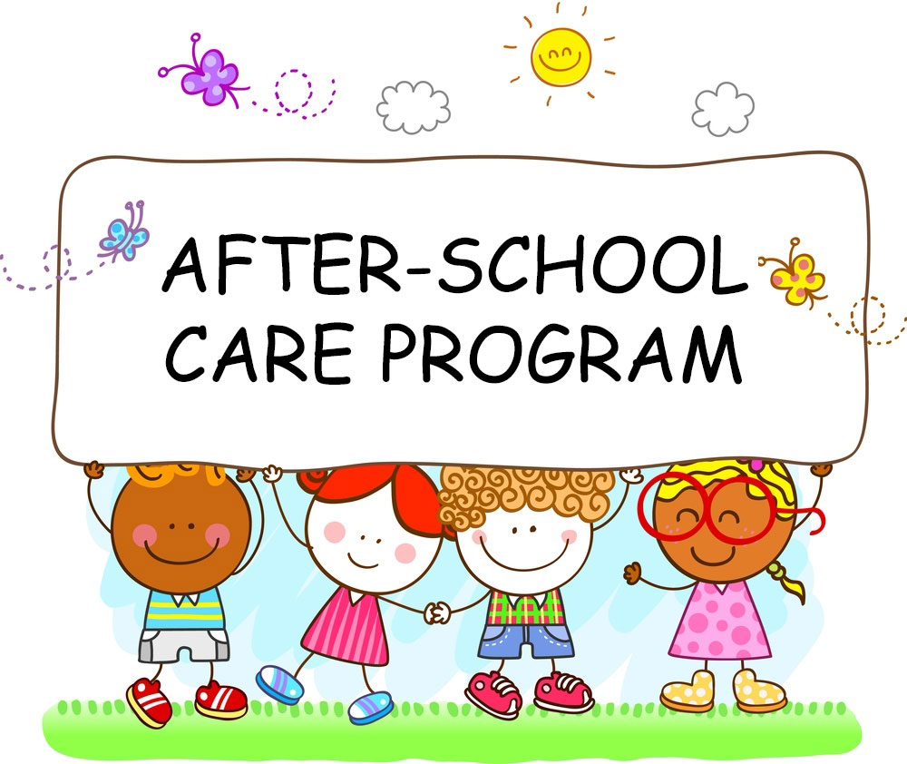

545 S. Third St.
Rogers City, Michigan 49779
989-734-3443
www.stignatiusparishschool.com
License No. DC710395593

St. Ignatius Catholic School
After-School Care Program
2024-2025 Parent Handbook

Welcome to St. Ignatius After-School Care Program. The following materials are considered important to your child’s safety and for the basic operation of the program. We welcome your suggestions as we all work together to make this a happy and worthwhile environment for both child and family.

Overview of School Program
The After-School Care Program provides professional care, supervision, recreation, and enrichment activities for school age children in grades kindergarten through sixth
. It serves working families who desire academics and supplementary after-school care in a Catholic environment for children enrolled in St. Ignatius Catholic School. For the safety of our students, all school employees and After-School Care workers are required by the Diocese of Gaylord to complete the Safe Environment training through VIRTUS and a thorough criminal back ground check. Our dedicated and loving staff members are committed in providing a safe environment for children.

Admission and Enrollment
All children attending the After-School Care Program must be enrolled students at St. Ignatius Catholic School. They are required to have a complete registration and medical release form on file with the school. These are available at the school office. If the program does not meet the needs of the child, he/she may be withdrawn. It may be possible that a child would need more supervision than we are able to provide.

Program Hours and Fees
The program begins at 2:45 PM until 5:30 PM each school day. Care will also be provided on half days of school from 11:45 AM until 5:30 PM. The prices for care are listed below. Exceptions include families with three or more children. The third and any additional children from a single family are free. All fees are to be paid monthly upon receipt of an invoice. Payment will be made monthly at the school office with checks made out to “St. Ignatius School.”

Full Days of School
Cost per family with one student
Pick up by 3:30 PM $5.00
Pick up by 4:30 PM $10.00
Pick up by 5:30 PM $15.00

Cost per family with two students
Pick up by 3:30 PM $9.00
Pick up by 4:30 PM $18.00
Pick up by 5:30 PM $27.00
Half Days of School
Cost per family with one student
Pick up by 3:30 PM $24.00
Pick up by 4:30 PM $30.00
Pick up by 5:30 PM $36.00

Cost per family with two students
Pick up by 3:30 PM $36.00
Pick up by 4:30 PM $45.00
Pick up by 5:30 PM $54.00

*Please note that care is being provided by a certified elementary teacher with an early childhood and special education endorsement.

Late Payment
Attendance for students will be suspended for non-payment.

Late Pick-Up
A fee will be added to the monthly bill, per student for late pick-up. There will be a charge of one dollar per minute after 5:30 PM per child, applied to the fee. Staff members are employed until 5:30 PM. It is only common courtesy to respect the time of closure.

Drop-In After-School Care
St. Ignatius After-School Care program is available on an all week schedule and also a drop-in or occasional basis. A request for drop-in care must be made 24 hours in advance and all registration and health forms completed. This will allow staff to know the number of children who will be present, to plan for the appropriate number of staff, and to stay within license parameters. To request drop-in care, call the School Office the day before you want to use the service. Indicate when you will pick your child(ren) up. The Program Director will okay the request, if the After-School Care enrollment is not full.

Activities
After-School Care will consist mainly of the following: Exercise in the gym or outdoors, snack, story time, home work hour, quiet games, reading and puzzles.

Snacks
A break time for snack will be provided. We ask that you provide your own snacks. Nutritious snacks are encouraged, such as: fruit, yogurt, granola bars, crackers, etc. Cookies, chips, or other sugary treats should not be a regular snack item.

Schedule of Operation/Emergency Closing
The program will follow the Rogers City Area Schools calendar. If the school closes for vacations, or cancellations due to weather conditions After-School Care is also closed. After-School Care will not run during Parent/Teacher Conferences or the day before a major school break.

STUDENT RESPONSIBILITIES
St. Ignatius Catholic School After-School Care Program is part of St. Ignatius Catholic School. We uphold the school mission statement and strive to nurture all children through a strong formation of faith, academic excellence, and compassionate discipline. Students are always to conduct themselves as St. Ignatius Catholic School students, and to exhibit the behaviors expected of such students.

Expectations for Student Behavior
As members of a Christian and caring community, the children will be expected to respect the staff, each other, and the materials and environment provided. They must never leave the building or grounds without explicit permission of the staff of the After-School Care program. Such permission will only be granted by order of the parent or guardian.

1. Each person has a right to personal safety and respect.

Fighting, name calling, gossiping, disrespect for persons’ bodies or harassment of any kind, or leaving the school building without permission are violations of safety and respect. The purpose of the harassment policy is to promote and insure a Christian, professional and supportive school environment for all parish employees, volunteers and students which is free from physical, psychological or verbal intimidation and harassment. The Diocese of Gaylord prohibits any form of harassment by anyone in the school setting. Harassment encompasses a broad range of verbal as well as physical behavior, which could include, but is not limited to:
- Physical or mental abuse
- Verbal intimidation, bullying, harassment or demeaning behavior;
- Racial insults;
- Derogatory ethnic slurs;
- Unwelcome sexual advances or touching;
- Sexual comments or sexual jokes.

2. Each person has the right to have his or her environment respected.

Behavioral disruption and failure to follow rules are examples of violations of respect for others.

3. Everyone has the right to have personal and community property respected.

Stealing, destruction or defacement of learning materials, personal belongings and furnishings are examples of violations of respect of property.

4. Each person has the responsibility to respect and follow the directives of those in authority.
Disrespect to authority, disobedience, failure to adhere to the dress code, and failure to follow consequences for actions, are examples of disregard for this responsibility.

Discipline
Children are expected to follow the rules of the St. Ignatius School Student/Parent Handbook for the school. A TIME OUT or separation from the group and activity will be used as needed. Violations will result in personal apologies, and may involve a conference with the authority involved, notification or conference with parents, reimbursement, and suspension of After School privileges or suspension/expulsion from the program. Any or all of the above consequences may be applied.

Parental Responsibilities
With the children’s safety and well being in mind, it is MOST important that the parent fill out an emergency health form and then adhere to the following rules:
- Parents or guardians will sign children out on the daily log. (daily control sheet)
- Parents or guardians should not take children from the schoolyard or other areas without notifying the After-School Care staff.
- Parents or guardians should not send persons whose names are not on the emergency card to ask for the release of children.
- Children that are unwell will be sent home. If a parent is unavailable an alternative care giver listed on the child’s health form will be called for pick up.

Volunteer Policy
1. For the safety of St. Ignatius students, parent and guardian volunteers are required by the Diocese of Gaylord to complete the Safe Environment Program, a criminal back ground check, and a Live Scan of fingerprints. This is mandatory for any parent volunteering with students for 8 or more hours per month.
2. All volunteers will work under the supervision of the certified teacher in attendance. This includes all parents or guardians with children in the program.

Illness or Accident
In cases which appear to be of minor nature, first aid will be administered on the premises. In cases which appear serious, the Program Director will make an effort to carry out instructions as given on the emergency form. Parents will be expected to make provisions for taking sick children home. The After-School Care program does not have the facilities to care for sick children.

Pest Management Program
Parents will receive advance notification of any chemicals and pesticides sprayed to control insects and weeds on the school premises as required by Michigan Department of Agriculture.

HEALTH CARE POLICIES

Health Practices and Policies:

- Hand Washing: The following procedures are considered best practice for hand washing for both staff and students. Hands should be washed as necessary and at the following times: after toileting, after assisting children in toileting, before eating, after eating, and before serving food or drinks.
- Using warm water (between the temperature of 60˚ F to 120˚ F)
  - Moisten hands with water and apply soap
  - Rub hands together vigorously until a soapy lather appears and continue for at least 30 seconds.
  - Rub areas between fingers, around nail beds, under fingernails, jewelry, and the back of hands.
  - Rinse hands under running water until they are free of soap and dirt.
  - Dry hands with a clean, disposable paper towel.
  - Dispose of the single service towel in a lined trash container.

- Handling bodily fluids: The following procedures are considered best practice for handling bodily fluids. Staff will always wear protective gloves when dealing with vomiting children or when changing a child’s wet or soiled clothing. Always wear latex gloves as a protective barrier for blood. Discard gloves used in these situations in proper waste containers. If children or staff comes into contact with blood, parents and the director will be notified so that you may be offered counseling through an appointed Health Professional.

- Cleaning and sanitizing of all equipment, toys and other surfaces: The following steps are followed for cleaning and sanitizing:
  - Wash the surface or article vigorously with warm water and detergent.
  - Rinse the surface with clean water.
  - Submerge, wipe or spray the surface or the article with a sanitizing solution.
  - Let the article or surface air dry.
  - If there is an outbreak of a communicable disease (such as pink eye), staff will clean all items in our center within 24 hours.

- Controlling infection, including universal precautions:
If a child becomes ill while in attendance (runs a fever of 100.5 or above, vomiting, repeated diarrhea, develops a rash, symptoms of pink eye, severe ear ache, extreme congestion, etc.) our staff will notify parents. If they cannot be reached, we will call the emergency contact on the enrollment form. Staff will isolate the child if necessary in the office area until the parent arrives. Children should not be brought to school for their class if these symptoms exist and the child has not been treated by a physician. Please keep your child at home until they are no longer contagious, or have been on antibiotics for 24 hours (if necessary).

- Health-Related Resources:
If parents have any questions regarding health-related issues feel free to
Contact St. Ignatius Catholic School.
Other resources in our area are:
American Red Cross of Northern Lower Michigan 1-800-691-6059
Department of Human Services: 989-734-2108
District Health Department: 989-734-4723
Poison Control Center: 1-800-222-1222

Electronics
Students attending After-School Care are not allowed to use any hand-held electronics; this includes iPods or MP3 players, PSPs or Gameboys, and cell phones. Our After-School Care provides enough activities that additional devices are not to be brought to school for after-school use.

Emergencies and Medication

1. An emergency student information form must be filled out and on file in the school office. If parents cannot be reached, emergency number contacts will be called for instructions or assistance.

2. Any medication (prescription or over-the-counter, including Tylenol and throat lozenges) dispensed at the school will require written permission and direction from the parents or guardian. All prescription medication will be sent to school in the container issued by the pharmacy. All medications will be kept in the office and will be dispensed from there by school personnel. No student may keep any medication in his/her possession, or administer his/her own medication. The only exception to this would be for a student to carry his/her own inhaler if there is a written note from the physician on file in the school office.

3. ILLNESS/INJURY – If a student is injured or becomes ill at school, these procedures will be followed:
a. Assessment of the situation
b. Common sense first aid
c. The principal will be notified
d. The parents or authorized person will be notified if necessary
e. The parents will decide if the child should stay in school, go home, or go to the hospital (doctor’s office) and they will make the necessary arrangements

4. SERIOUS ACCIDENT/INJURY – If a student is involved in a serious accident or injury at school, these procedures will be followed:
a. Assessment of the situation by the principal
b. Common sense first aid
c. The parents will be notified and decide if the child should stay in school, go home, go to the hospital (doctor’s office), and they will make the necessary arrangements
d. In the event the parents cannot be reached right away, the principal will follow the instructions on the student’s emergency form as to where the child will be taken (hospital or doctor’s office)
- A report form will immediately be completed noting the circumstances of the accident or injury and filed with Gallagher Bassett, the Michigan Catholic Conference Insurance Company, in compliance with their regulations
5. A fire drill program consisting of at least 1 fire drill quarterly shall be established and implemented.

CRITICAL INCIDENT POLICY
In an effort to insure as much as possible the safety of all persons within our school building and grounds the following procedures have been instituted as components of our Critical Incident Policy

- All doors into the school building are kept in a locked position during the school day.
- All parents, guests, and visitors are required to sign in at the office and wear a Visitor Identification Badge.
- Classroom doors are to be kept in a locked state at all times.
- Rogers City Area Police Department Critical Incident Procedures.
- Emergency Procedure:

Hallways are cleared of students and visitors – everyone is secured in classrooms or waiting areas.

Classroom doors are locked, lights off, windows are covered

Students are moved to inside classroom walls, out of sight

Students are reassured and kept calm and quiet

Wait for all clear from the office or authorities

No one is allowed to enter or exit the building except critical incident authorities

Lock Down Secure Mode:

School is in a lock down mode – no outside recess or outside activity

School classes continue as usual

Wait for all clear from the office or authorities

Bomb Threat:

All personnel check for anything suspicious

Evacuations are coordinated with the police or fire department and may include shelter in St. Ignatius Church or Rogers City Area Schools Gym

Wait for all clear from authorities

Parents are not to come to the school for their children during any critical incident. In addition, phone lines must remain clear for use by authorities. The doors will not be opened once we lock the students in until the critical incident is under control. The schools in Rogers City have had this training, as well as all law enforcement personnel so that the procedure followed will be the same. Authorities assume control in the event of a critical incident and will determine when it is safe to open the school. All media information is disbursed in cooperation with the Diocese of Gaylord, the school administration, and the pastor.

The school will practice critical incident modules during the school year. All completed critical incident school practices will be posted on the school website.

If a critical incident would occur while children are outside at recess, the students would be taken into the school building for shelter in place safety.

A Weapons Policy is part of our Student Handbook.

In accordance with state requirements, three lockdown drills are conducted during the school year. Every adult and child within the building will participate in these drills. Instruction for participation is given at the beginning of the school year and reviewed periodically throughout the year. The entire school will be locked and no one will be allowed to enter the building during a lockdown drill.

Exclusion & Withdrawal Policy

Exclusion of children from out-of-home childcare settings has been recommended for illnesses known to be transmitted among, by, and to children when exclusion of the child or adult has a potential for reducing the likelihood of secondary cases. Exclusion has also been recommended in cases of serious illness for which a hypothetical risk of transmission exists, but for which data at present is insufficient to quantify the risk. In many situations, the expertise of the program’s medical consultant and the responsible local and state public health authorities are helpful in determining the benefits and risks of excluding children from their usual care program.

Children should be excluded from the child care program if any of the following conditions are present:

- The illness prevents the child from participating comfortably in program activities.
- The illness results in a greater care need than the childcare staff can provide without compromising the health and safety of the other children.
- The child has any of the following conditions: fever, unusual lethargy, irritability, persistent crying, difficult breathing, or other signs of possible severe illness.
- Diarrhea (defined as an increased number of stools compared with the child’s normal pattern, with increased stool water and/or decreased form) that is not contained by diapers or toilet use.
- Vomiting two or more times in the previous 24 hours, unless the vomiting is determined to be due to a non-communicable condition and the child is not in danger of dehydration.
- Mouth sores associated with an inability of the child to control his/her saliva, unless the child’s physician or local health department authority states that the child is noninfectious.
- Rash with fever or behavior change, until a physician has determined the illness not be a communicable disease.
- Purulent conjunctivitis (defined as pink or red conjunctiva with white or yellow eye discharge, often with matted eyelids after sleep and eye pain or redness of the eyelids or skin surrounding the eye), until examined by a physician and approved to readmission, with or without treatment.
- Tuberculosis, until the child’s physician or local health department authority states that the child is noninfectious.
- Impetigo, until 24 hours after treatment has been initiated.
- Streptococcal pharyngitis, until 24 hours after treatment has been initiated and unless the child has been afebrile for 24 hours.
- Head lice (pediculosis), until the morning after the first treatment.
- Scabies, until after treatment has been completed.
- Varicella, until the sixth day after the onset of rash or sooner if all lesions have dried and crusted.
- Pertussis (which is confirmed by laboratory or suspected based on symptoms of the illness or because of cough onset within 14 days of having face-to-face contact with a person in a household or classroom who has a laboratory-confirmed case of pertussis), until 5 days of appropriate antibiotic therapy (currently: erythromycin) has been completed (total course of treatment is 14 days).
- Mumps, until 9 days after onset of parotid gland swelling.
- Hepatitis A virus infection, until one week after onset of illness and jaundice, if present, has disappeared or until passive immunoprophylaxis (immune serum globulin) had been administered to appropriate children and staff in the program, as directed by the responsible health department.

If a child is presenting any of the following symptoms or behaviors, the school secretary will contact parents/guardians immediately via phone to notify them that their child is unwell. The ill child will stay in the school office until their parent or guardian is able to pick them up. Parents will be informed about the symptoms that the child is presenting and given a recommendation about when they may return to school.

Weapons Policy

St. Ignatius Catholic School will not allow weapons in school or on school property. “Weapons” shall be defined as, but not limited to, guns, firearms, knives, clubs and explosive devices. The administration reserves the right to determine what constitutes a weapon. A student who is found to be in possession of a weapon will be immediately removed from the student population, and appropriate disciplinary action will be taken. Likewise, St. Ignatius Catholic School will not accept for enrollment any student who has been expelled from another school for violation of its weapons policy.

MISSION STATEMENT OF ST. IGNATIUS SCHOOL

St. Ignatius Catholic School provides a Christian education through the cooperation of our families, the primary teachers of our children. Guided by the Holy Spirit, the love of God, and Christ-like living, St. Ignatius is committed to nurturing all children through a strong formation of faith, academic excellence, and compassionate discipline
St. Ignatius Catholic School After-School Care Form for the 2024-2025 School Year

Parent Notification of Licensing Handbook
The licensing notebook contains all the licensing inspection and special investigation reports and related corrective action plans for the last 5 years.
The licensing notebook is available to parents during regular business hours.
Licensing inspection reports, special investigation reports, and corrective action plans from at least the past 3 years are available on the department’s child care licensing website at www.michigan.gov/michildcare.

Annual Child Health Statement
I certify that my child is in good health with no activity restrictions noted. My child’s immunizations are up-to-date, and his/her immunization record or appropriate waiver is on file at St. Ignatius School. I will notify St. Ignatius School in writing of any activity restrictions that may pertain to my child in the future.
Circle yes/no if your child has restrictions. Please note the restrictions below.
Restrictions:_____________________________________________________________

Aftercare Acknowledgement
- I understand the After-School Care program will utilize our current playground equipment, which has not undergone a playground safety inspection by a certified playground safety inspector.

- I have received a copy of the After-School Care Program Handbook and agree to the policies and guidelines of this program

- I understand that the licensing notebooks is kept in the school office.

- This letter is to inform the parents and guardians that the Aftercare Program and Preschool Classrooms are licensed programs. These programs maintain a licensing handbook in compliance with the State of Michigan Department of Licensing and Regulatory Affairs. All parents and guardians of children are enrolled in the aftercare program were mailed a copy of the Aftercare Handbook in August 2024. By signing this document, you are verifying that you have received a copy of the handbook and are aware that we maintain and follow licensing rules and regulations.
I have read the above statements issued by St. Ignatius Catholic School.
_______________________________________________________________________
Children’s Name(s)

________________________________________________________________________
Parent Name

________________________________________________________________________
Parent/Guardian’s Signature Date

*Please tear off this page and return it to the school office.

